

Dynamics 365 Education Accelerator

Walkthrough Guide

Published: January 29, 2021

Accelerator Release Version: 3.1.3

File Name: Education.Accelerator.Walkthrough.Guide.docx

Table of Contents

Overview 3

Higher Education 3

Installing the Higher Education Accelerator 3

Personas 5

Walkthrough the Student Journey 5

Step 1: Updated Student Portal 5

Step 2: Advisor connection via Tele-advising 6

Step 3: View Personalized Progress 7

Step 4: Advisor dashboard 8

Step 5: Simplified course selection process 9

Step 6: Events within reach 11

Step 7: Uncomplicated internship process 11

Step 8: Instant access to program information 12

Step 9: Easy access to alternative funds 12

Step 10: Validations and insights 13

Step 11: Seamless integration from student to partner 16

K12 Education 16

Overview 16

Personas 16

Walkthrough the Parent or Student Journey 17

Step 1: Relevant information at your fingertips 17

Step 2: Get involved via Extra Curricular Activities 19

Step 3: Paperwork in its place 20

Walkthrough the Administrator and Educator Scenarios 20

Step 1: K12 Model Drive App 20

Step 2: Engage your donors, raise funds 21

Step 3: Student behavior management 22

Step 4: Educator – Update Attendance Easily 22

Step 5: Educator – Analyze Attendance Patterns 23

# Overview

The Common Data Model helps customers eliminate data silos, enable power insights, and take actions on their own data. This need is nowhere more relevant than in Education where data often deals with students and their ability to navigate a complex system to reach their goals. Microsoft is working closely with Education ISVs around the world to make the Common Data Model more relevant to them, by shaping the roadmap for Education Accelerator with them. Microsoft and the Dynamics 365 team are dedicated to enabling ISVs, Partners, and Customers to build and focus their efforts on vertical industries in a streamlined approach. The accelerators provide a uniform platform for those who wish to connect, embed, or extend the Dynamics 365 platform and Power Platform. The Education Accelerator has a core component, a higher education component, and a K12 (primary and secondary schools) component.

This documentation provides a walkthrough of the key dashboards and flows within the Education offerings both higher education and K12.

# Higher Education

The Higher Education scenario is released to sit on top of an existing Dynamics instance and assist with day to day operations or as a stand-alone data model for developers. The Accelerator contains installable scenarios that include standard entity attribute extensions, new higher education entities, pre-built dashboards, sample data, and other tools to help customers and partners build and deploy new solutions.

As colleges continue to navigate online and hybrid mode of learning for students, we’ve released an update for student success and tele-advising to the higher education component of the education accelerator. In the section labeled Walkthrough the Student Journey, you’ll find more details about these additions and updates.

This documentation provides an updated walkthrough of the key dashboards and flows within the higher education scenario.

## Installing the Higher Education Accelerator

*Please note this Test Drive:

* May include capabilities not yet available for download
* Is read-only
* Is limited in duration

To install the Higher Education Accelerator, follow this process:

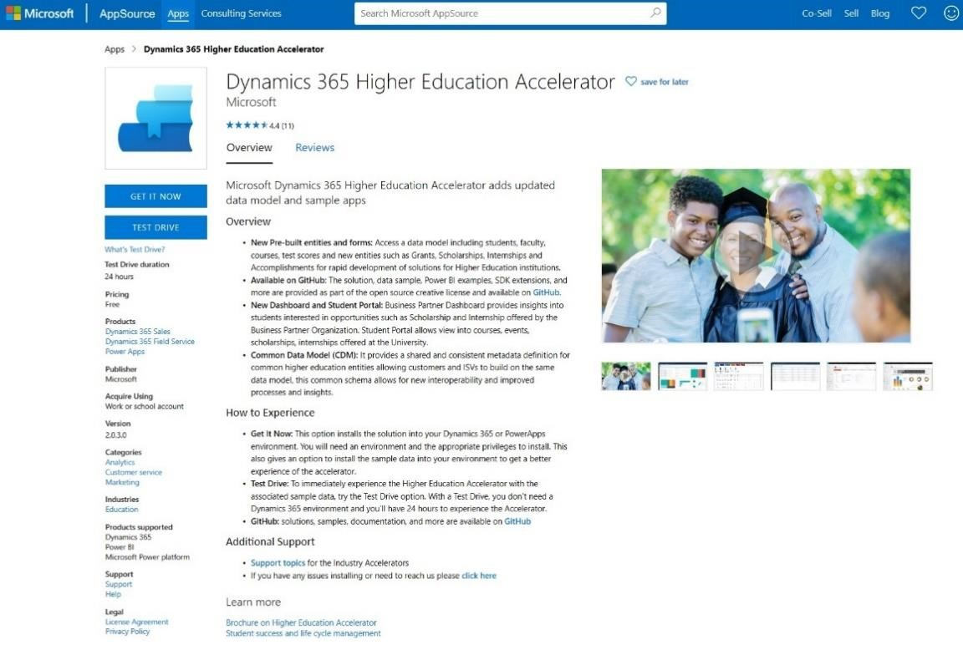

* Select the Test Drive button for the Higher Education Accelerator from [AppSource.](https://appsource.microsoft.com/en-us/product/dynamics-365/mshied.highereducationcommondatamodel?tab=Overview) Sign in.

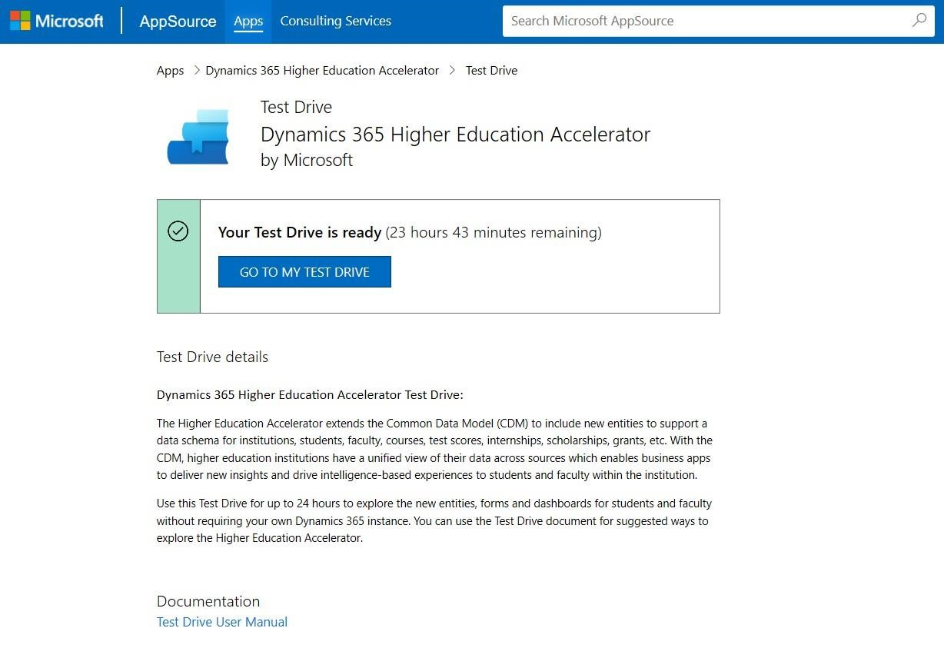

* Once the Test Drive is available, select the Go to My Test Drive button.

## Personas

The walkthrough document was created with the following Personas in mind:

1. University Administrator
   1. The University Administrator manages all University operations including personnel, budget, curriculum, and policy
2. Business Partner
   1. The Business Partner is an individual or company who has some involvement with the University
3. Student
   1. A student is the person studying at a University
4. Advisor
   1. An advisor is a staff member who support students to help them meet their academic goals.

This demo walks you through the various ways a Student, University Administrator, Business Partner, Advisor interacts with the Higher Education Accelerator.

## Walkthrough the Student Journey

## Step 1: Updated Student Portal

Anton Chew logs into the new student portal and is instantly impressed by an updated design and user experience.

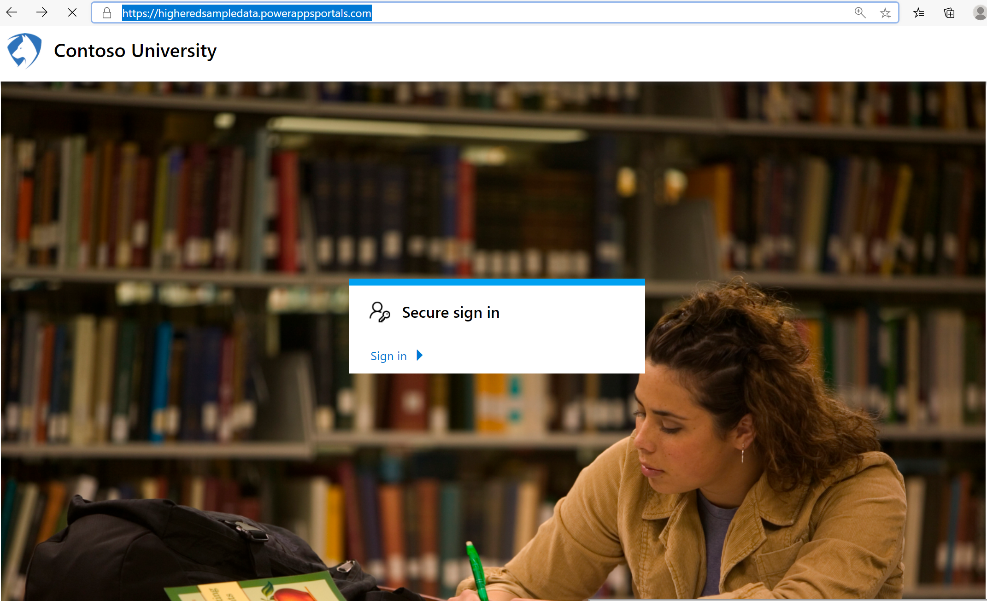

## Step 2: Advisor connection via Tele-advising

Anton uses the **connect with advisor** link, on the left-hand navigation bar, to schedule a meeting with his advisor.

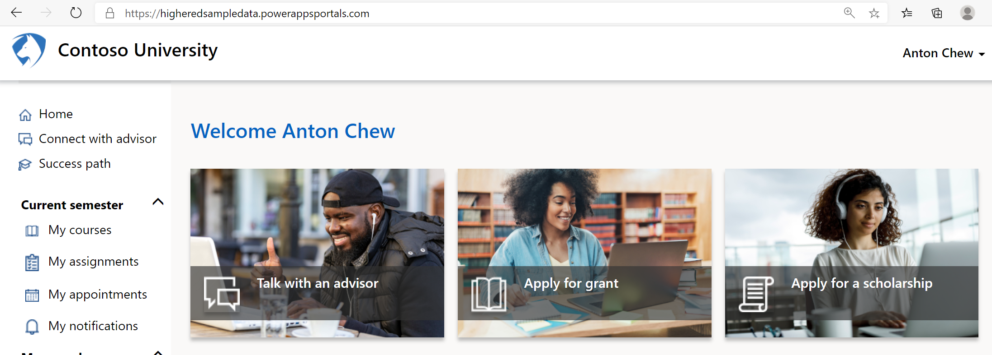

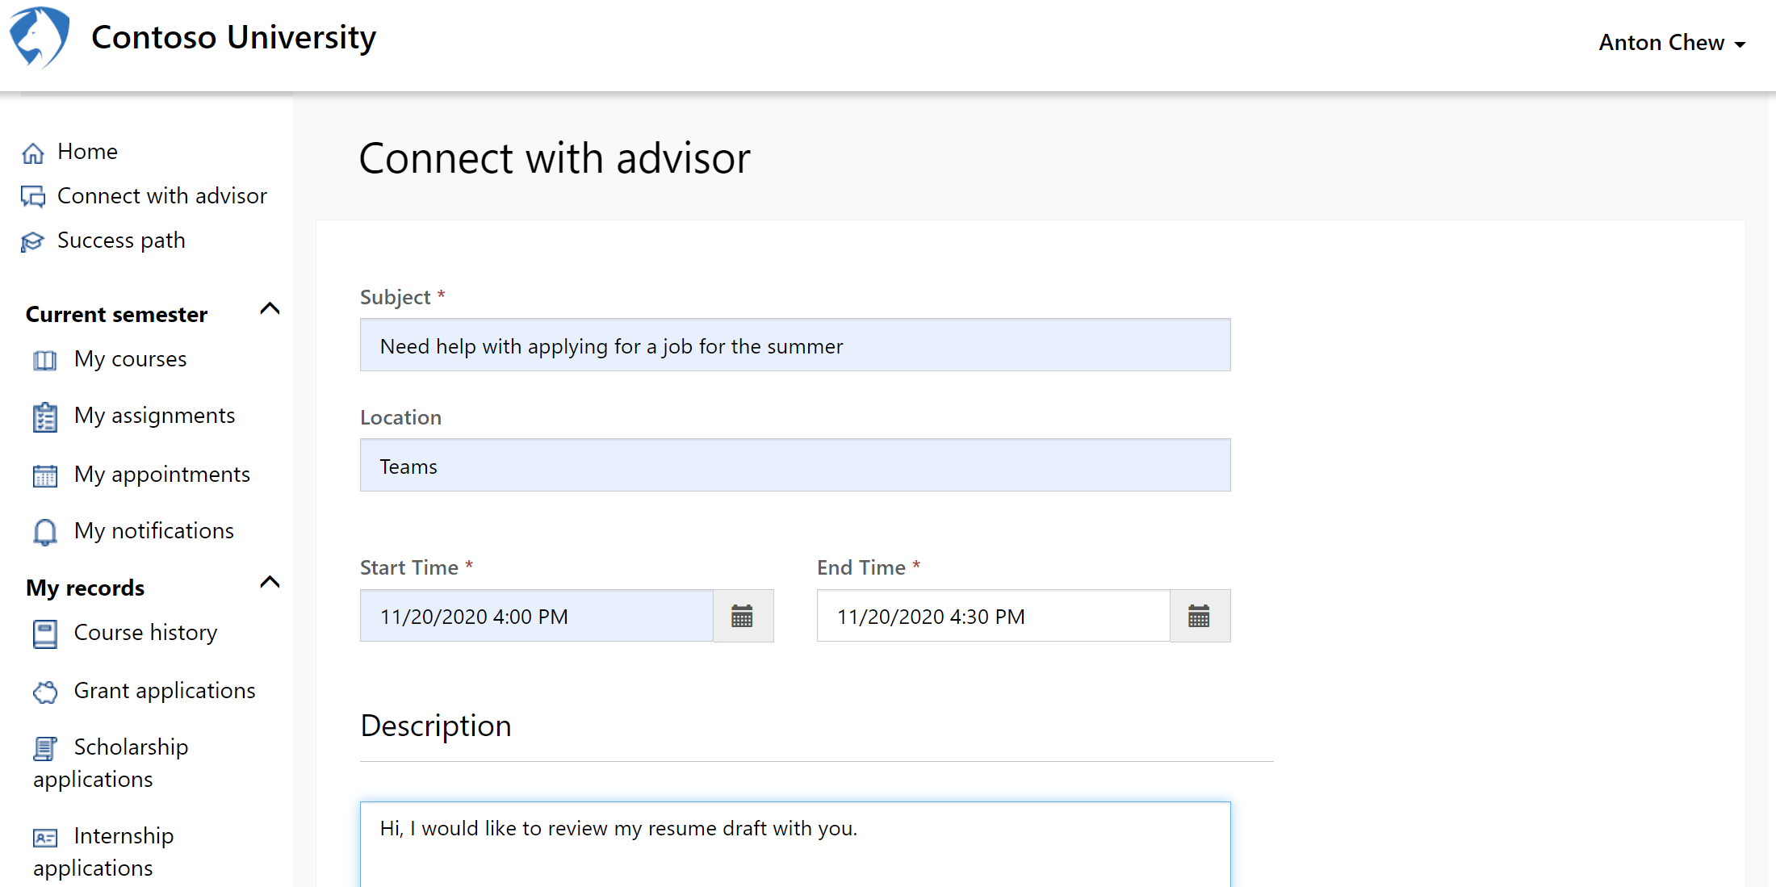

Anton creates an appointment request with a date and time to work with his busy schedule. In the description box, he adds a brief explanation for the meeting request. This description helps his advisor prepare for the meeting.

## Step 3: View Personalized Progress

Anton is curious about his progress toward his bachelor’s in accounting.

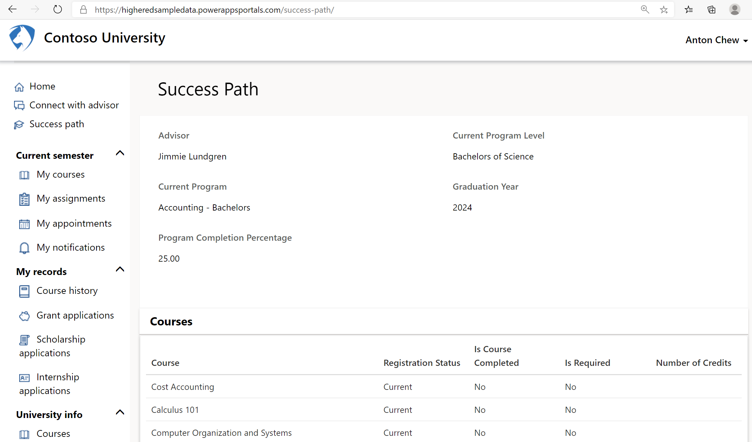

On the **success path** screen, Anton views the courses needed toward his degree, both completed and not completed, and views he has currently achieved 25% of the program requirements. This percentage increases as he completes additional required courses.

## Step 4: Advisor dashboard

Jimmie Lundgren, an advisor at Contoso University, logs into the **HigherEd power app**, and views the advisor dashboard. Via this dashboard, as an advisor Jimmie can see his top and bottom performing students as well as upcoming appointment he has with students. He can prioritize where to spend his limited time based on quickly understanding the needs of students in his charge.

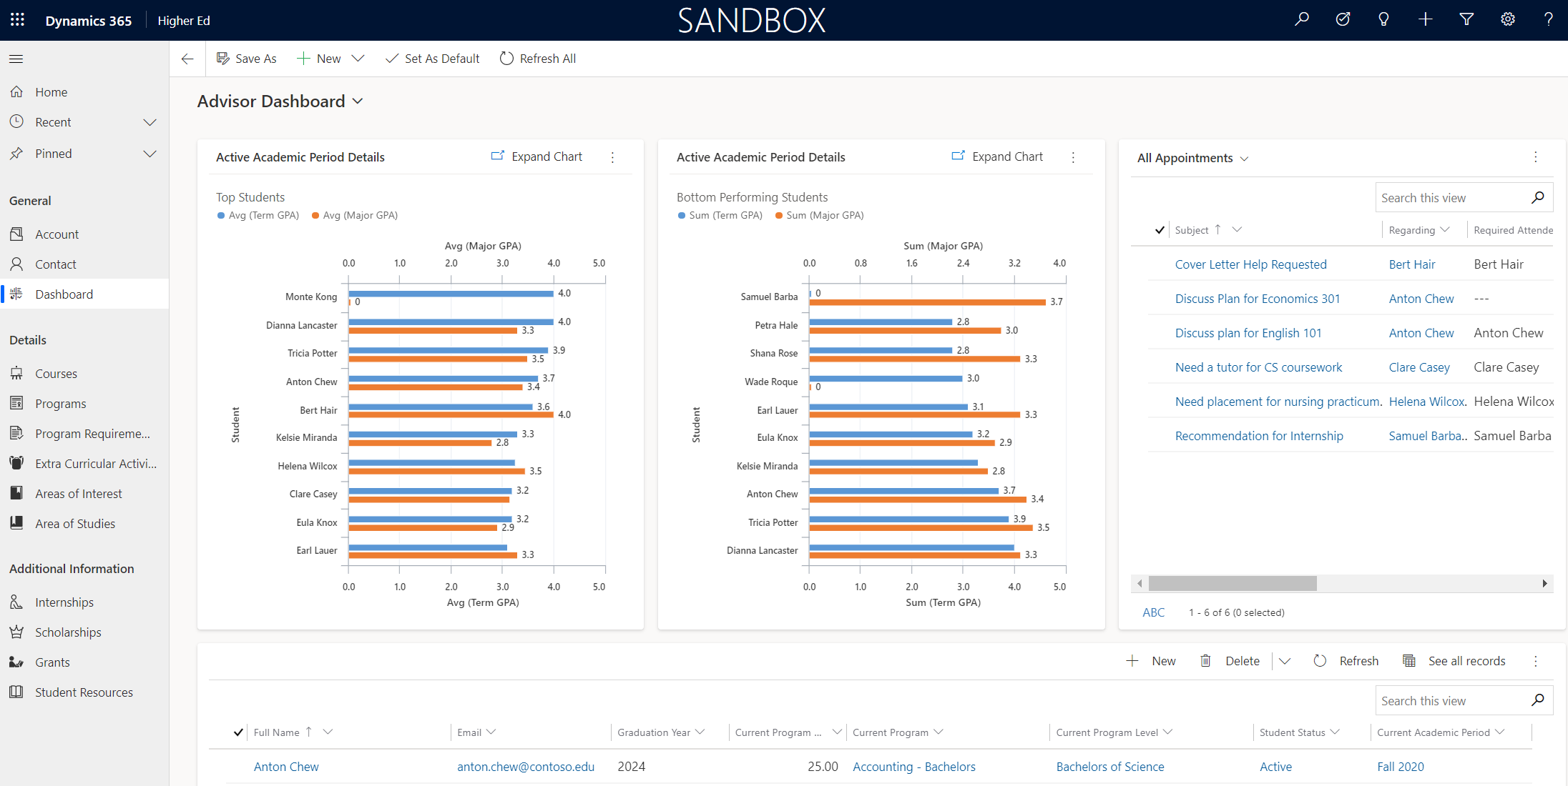

Via this dashboard, Jimmie reviews a high-level view of which students are high performing and low performing as well as upcoming appointments with students. This view helps him understand his students needs and prioritize where to spend his time.

## Step 5: Simplified course selection process

Anton Chew opens the Contoso University student portal to view his available courses. This PowerApps student portal can be found at [https://highereducation.powerappsportals.com.](https://hiedacceleratordemo.powerappsportals.com/)

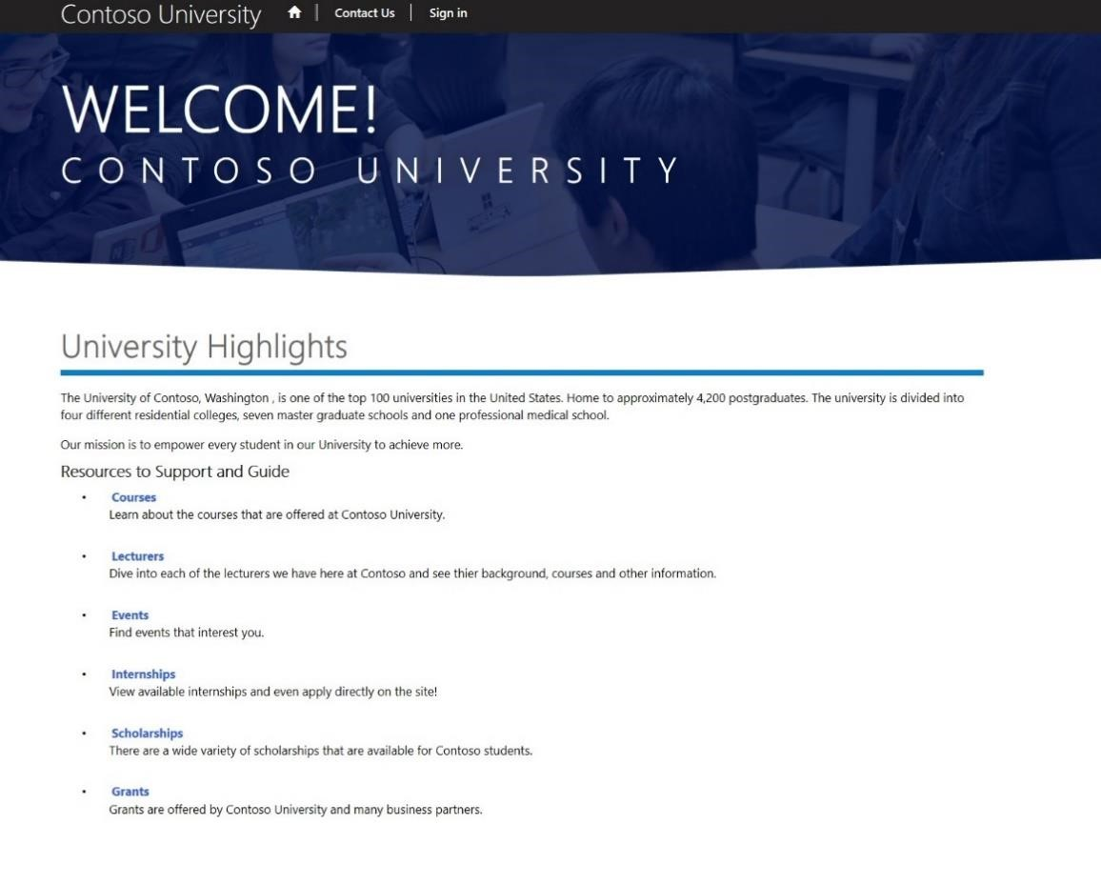

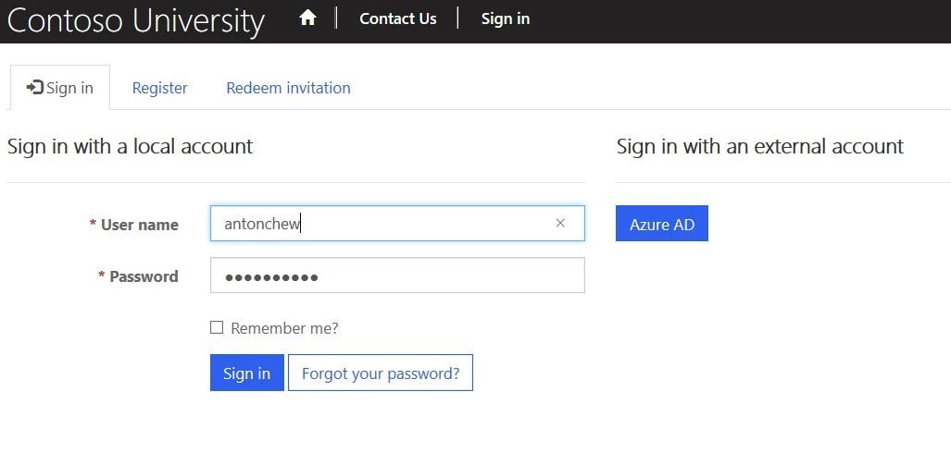

Anton logs in in with his Username: antonchew and Password: pass@word1.

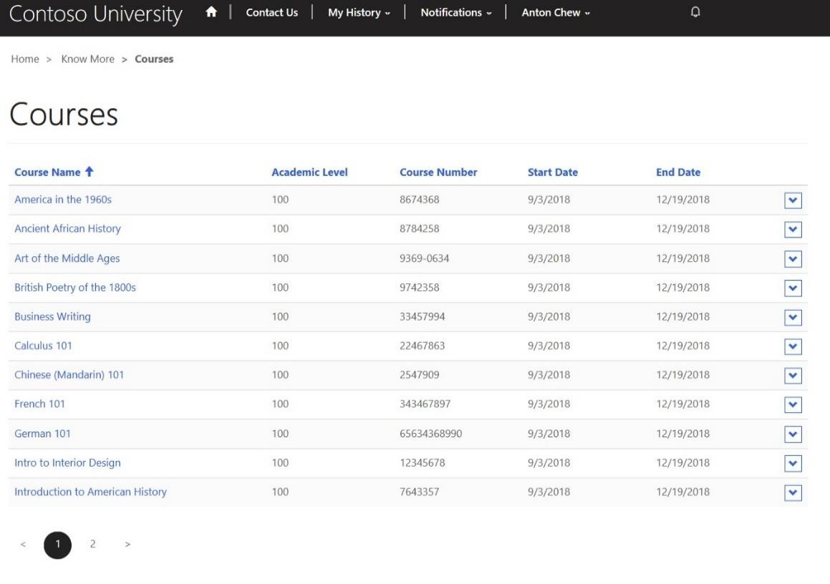

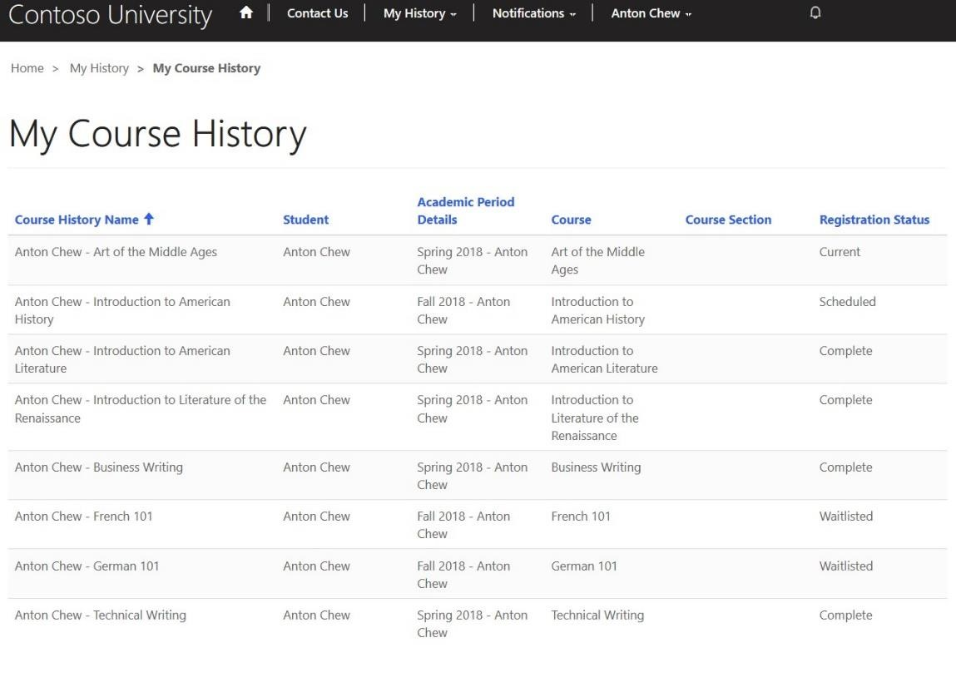

He explores all the courses available, reviews their descriptions, and selects the courses he would like to take. (Please note course selection is not available in the demo version.) Then Anton reviews his course history.

## Step 6: Events within reach

Now that Anton has registered for next semester’s courses, he is interested in adding some events to his calendar. On the Student Portal Events page, he finds a seminar on software engineering which sounds interesting. After reading the details he easily signs up for it, right within the app.

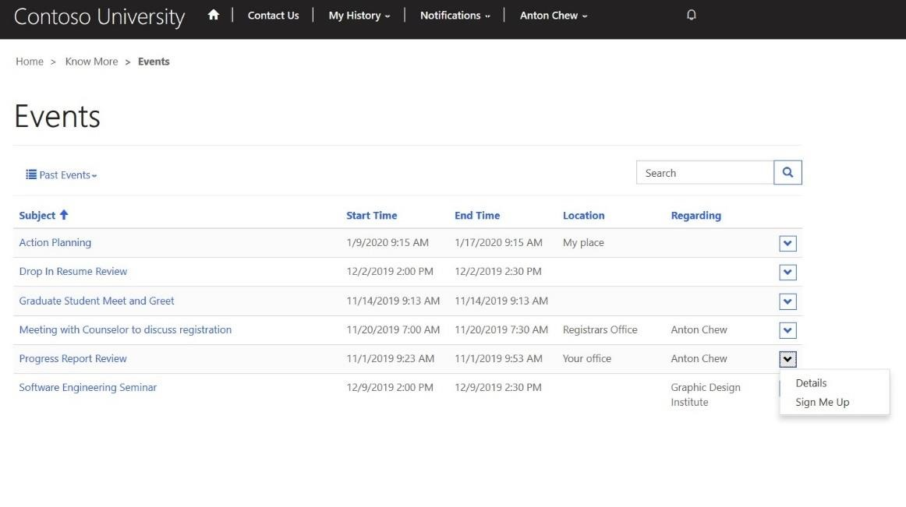

## Step 7: Uncomplicated internship process

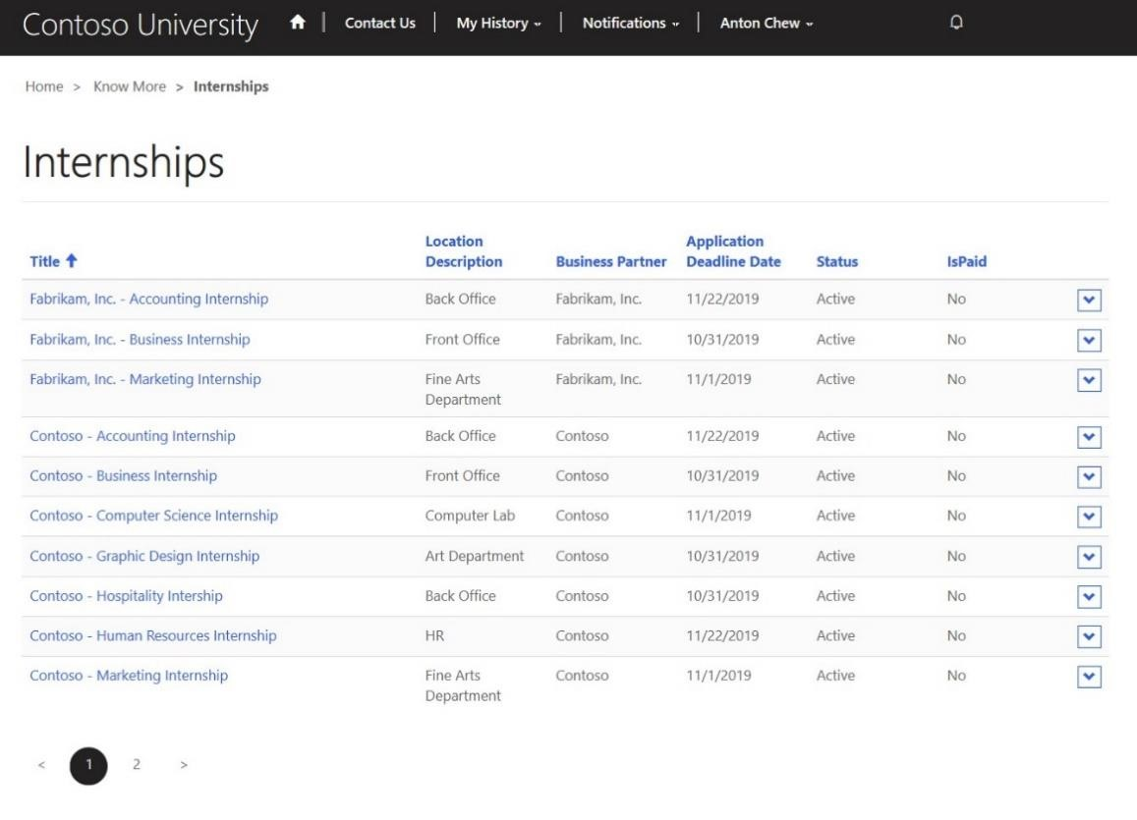

Anton checks available internships within the portal. After looking through the list and reading more details, he finds three internships which interest him. He easily applies. After a few days he comes back to check the status of his internship applications and sees that he has two offers pending.

## Step 8: Instant access to program information

Anton is interested in learning more about the master’s in accounting program at Contoso University. Without having to go to campus or even make a call, within the Student portal he quickly chats with a chat bot and learns more about the accounting program.

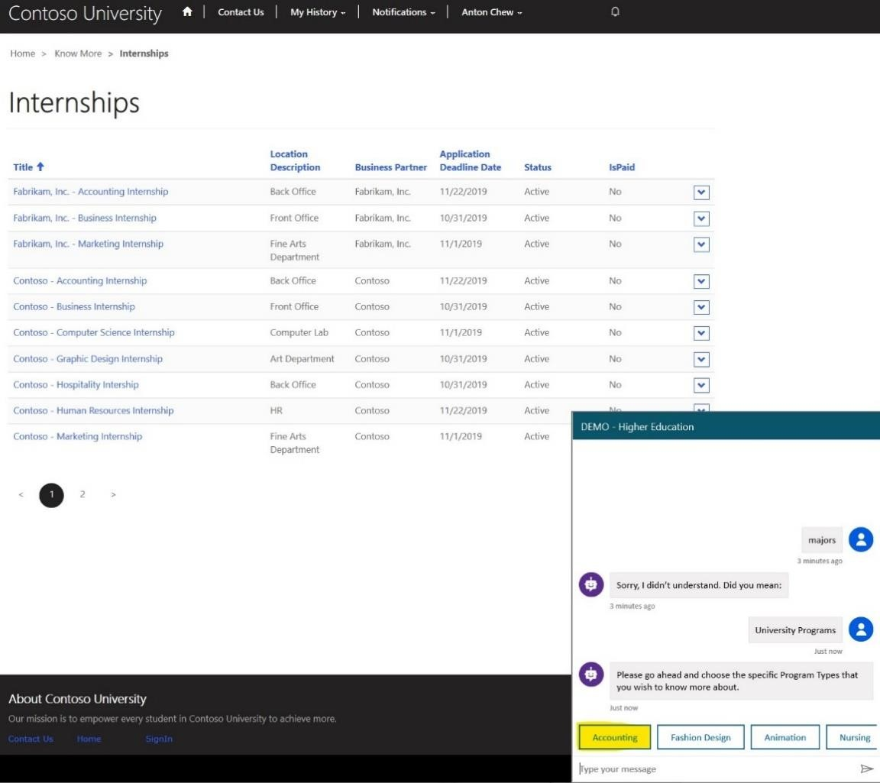

## Step 9: Easy access to alternative funds

Anton needs to find alternative ways to pay for his University expenses. He views available scholarships and grants and finds several that he qualifies for. He effortlessly applies for them within the portal.

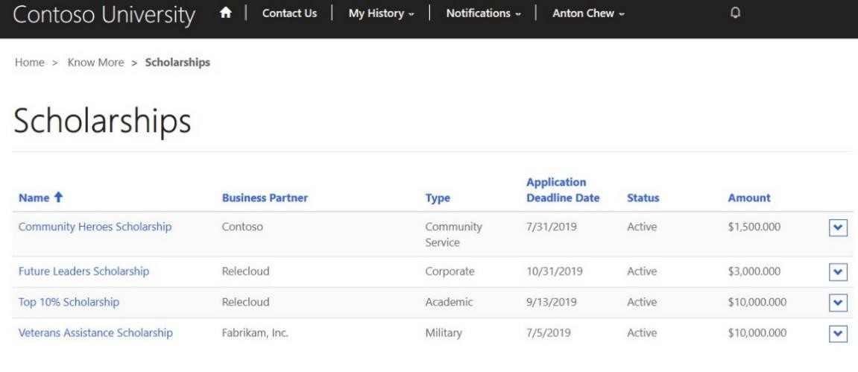

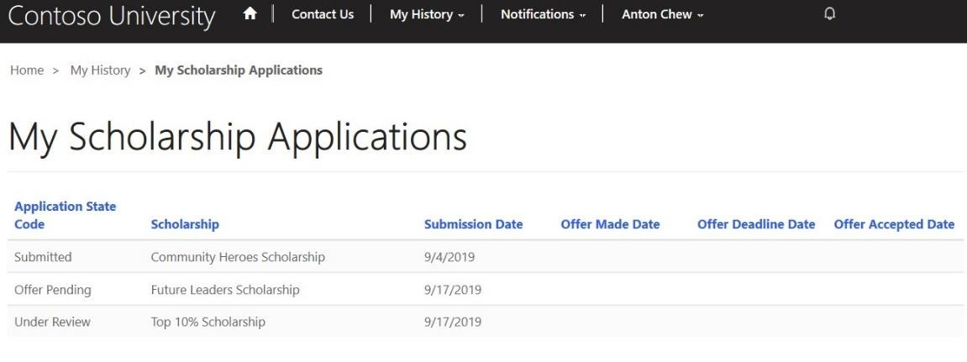

He feels fortunate that he doesn’t have to wait on hold to check on the status of his applications, but instead he is able to check the status as often as he wants with ease.

## Step 10: Validations and insights

To assist Anton and all students, the University Administrator uses the Higher Education Accelerator to manage the University’s operations. They use at the Business Partner Dashboard to view insights into the number of grants, scholarships, and internships offered by each business partner along with the area of study associated to the grants. This view also shows insights into the status of student applications.

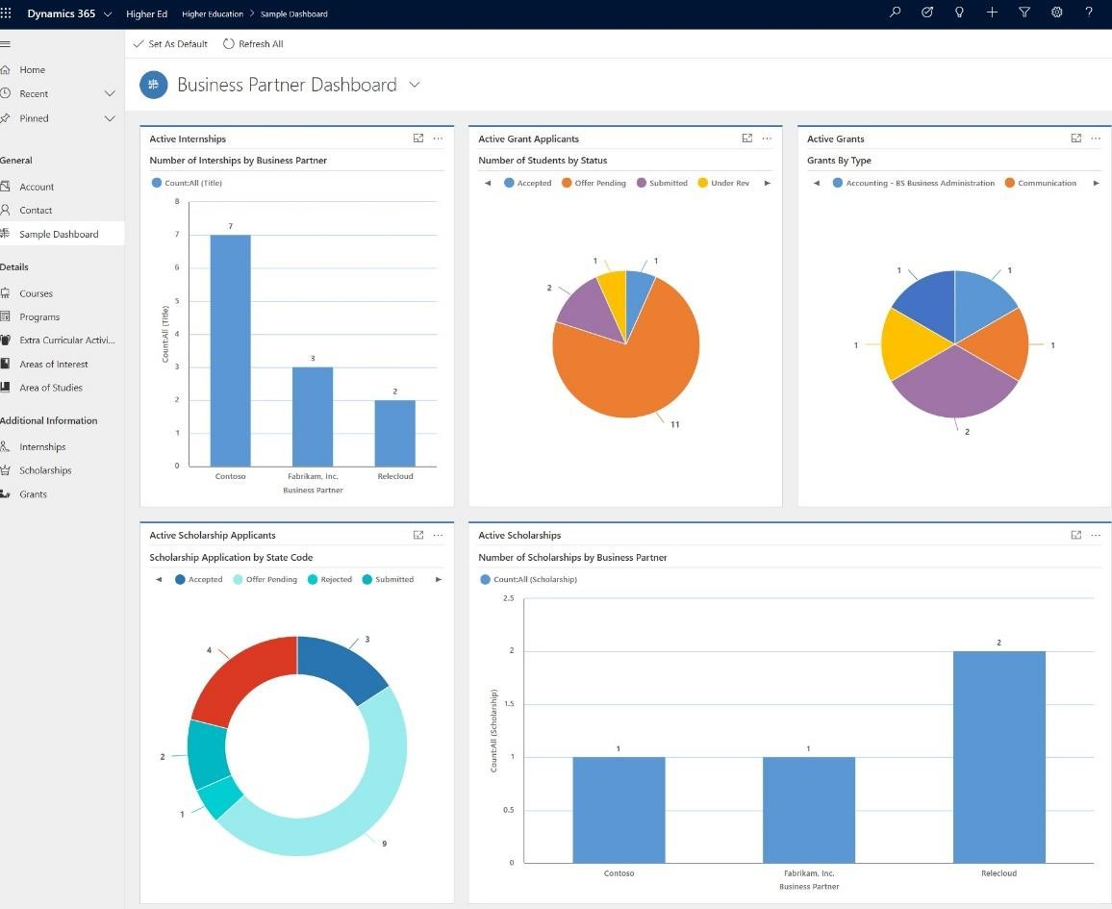

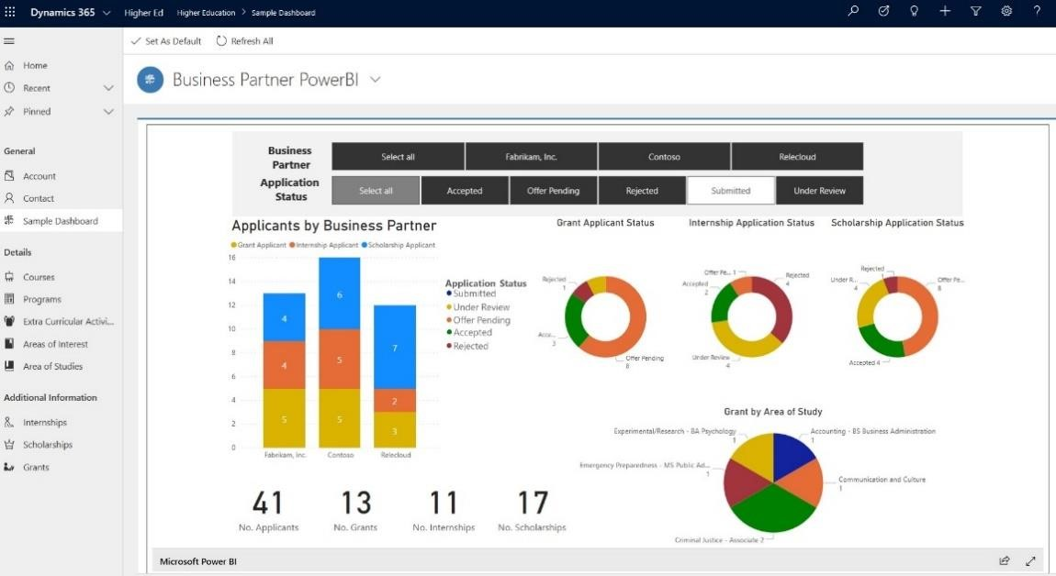

For a more holistic view, the University Administrator looks at PowerBI details and drills down into a specific Business Partner. This information guides them on ways to help their students, like Anton.

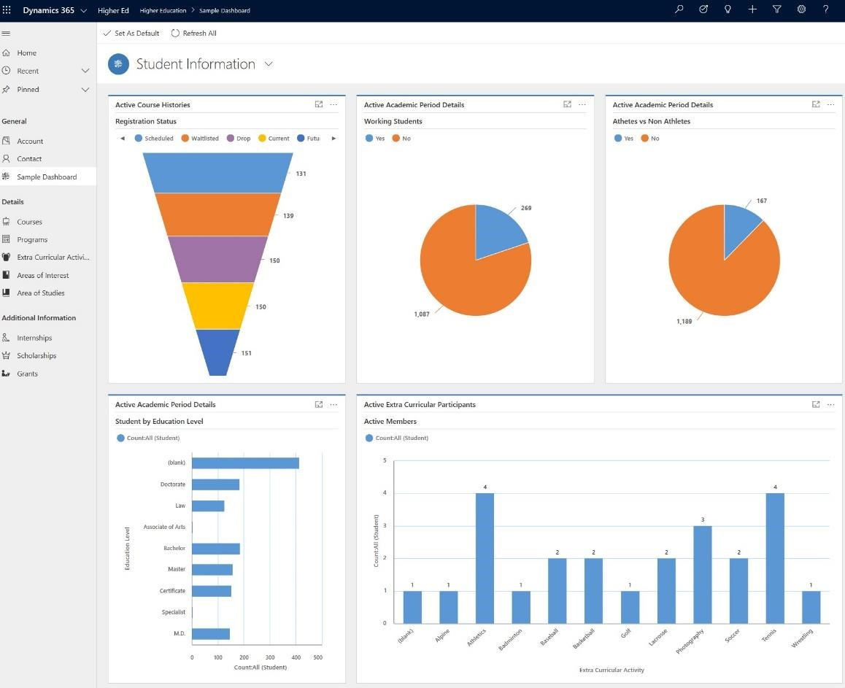

The University Administrator then looks at the Student Dashboard to view the general student status. This gives them insights into the bandwidth of the organization and students as well as how the students spend their time outside of University. They easily drill down into areas, like extra-curricular, within the dashboard to learn more.

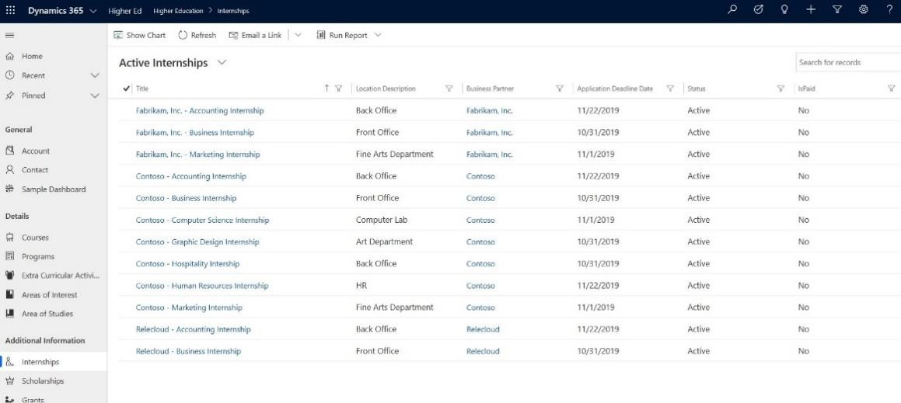

They look for gaps in areas like internships, scholarships, and grants to see how they can help more students.

## Step 11: Seamless integration from student to partner

The University Administrator works with Business Partners to bring more internships, scholarships and grants to their students. The Business Partner effortlessly uses the Higher Education Accelerator to review existing applicants and their application status.

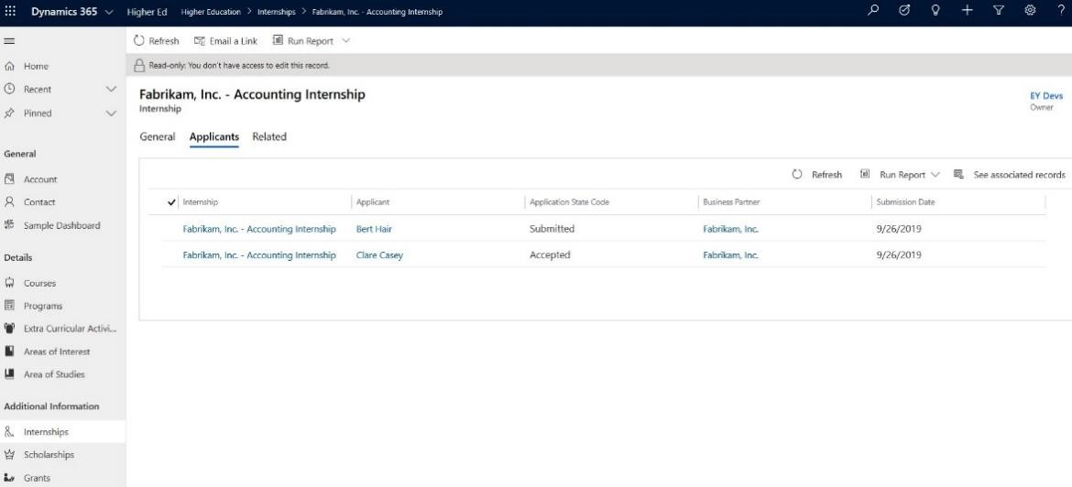

The Higher Education Accelerator provides Contoso University a seamless and easy to use portal for all their students, setting their university apart from others.

Thank you for completing the Education Accelerator Test Drive.

# K12 Education

## Overview

The K12 scenario released to sit on top of an existing Dynamics 365 instance or Power Platform instance to assist with day to day operations or as a stand-alone data model for developers. The holistic student profile and educator and community engagement scenario contains the data model, installable scenarios (including standard entity attribute extensions, K12 specific education entities, pre-built dashboard and portals, sample data) and other tools to help customers and partners build and deploy new solutions.

This documentation provides a walkthrough of the key dashboards and flows within the K12 scenario.

## Personas

The walkthrough document was created with the following Personas in mind:

1. Parent
   1. Parent who wants to be involved in student’s success
2. Admin/Educator
   1. Admin or Educator that wants to access, understand, and act against student data

Below you will be able to see the experience for the personas described above and how they can be utilized in a school setting.

## Walkthrough the Parent or Student Journey

## Step 1: Relevant information at your fingertips

Anton Chew, a student at Contoso High School, missed his Math class today. Knowing his teacher daily adds new assignments online he logs into his school account to learn what he missed.

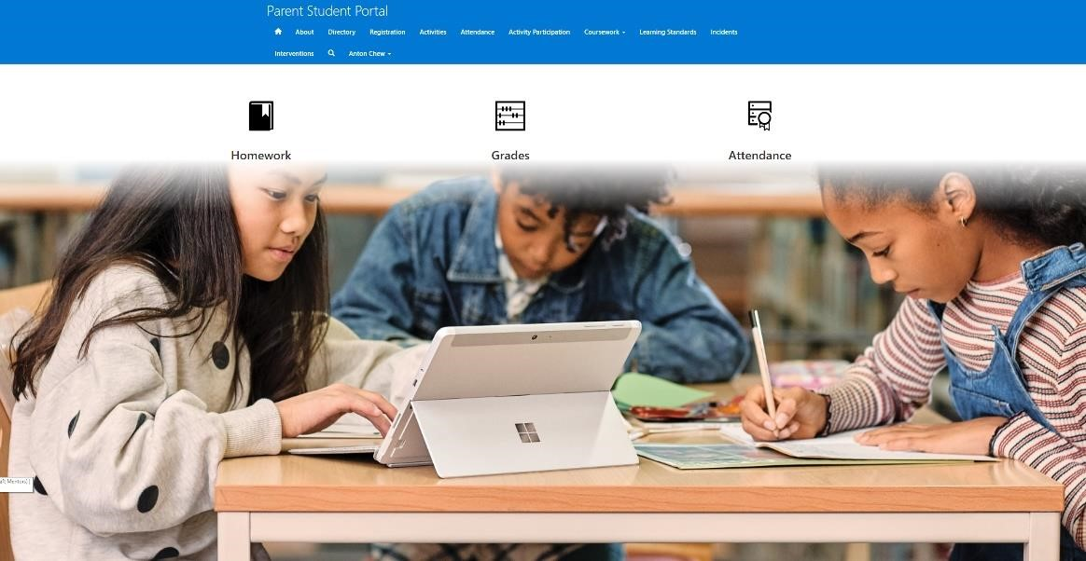

Navigate to the Parent Student Portal at <https://parentstudentportal.powerappsportals.com/>and log in using Anton’s credentials to see his view, Username: stuartulmer and Password: pass@word1. This portal allows both the parent and student access to the student’s information. From attendance to grades it facilitates clear conversations about progress made by students and caregivers/parents who support their students.

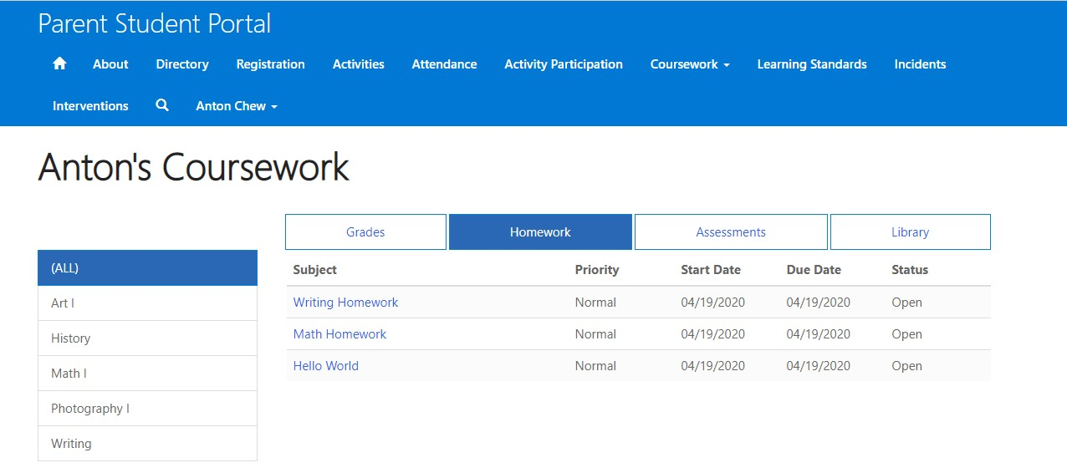

Anton goes to his Coursework tab and looks at his assignments. Here he sees all his assignments and progress made with each. He wants to focus only on his Math homework, so he navigates to the Math tab to see only those assignments.

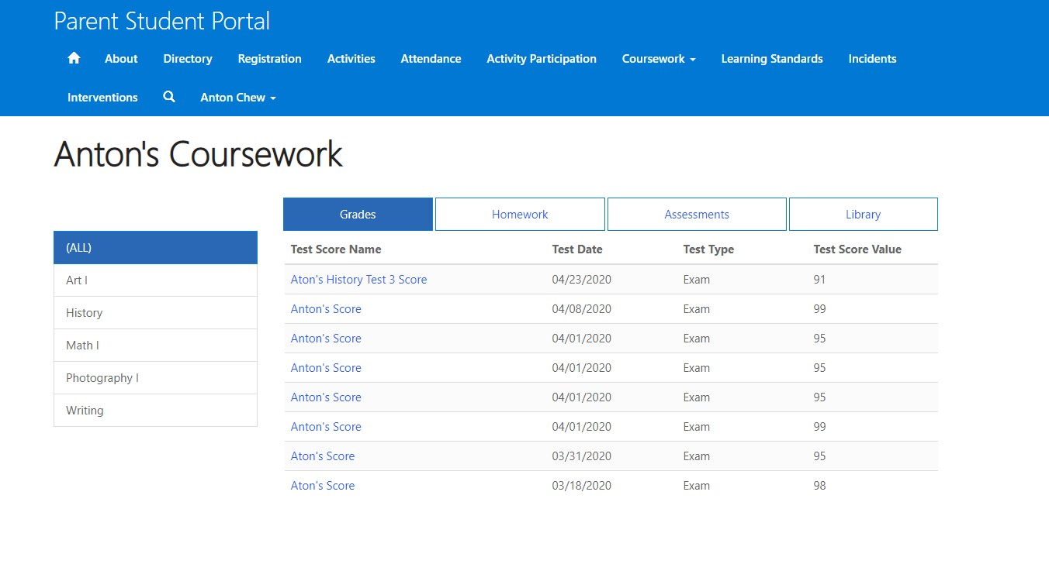

Anton completed a very hard History test and knows there is no hiding his progress from his mom, so he checks to see his grade before she asks. He views all his grades together but since his History class has been his most challenging, he focuses in on History itself. He is happy with his grade and cannot wait to share the news with his mom!

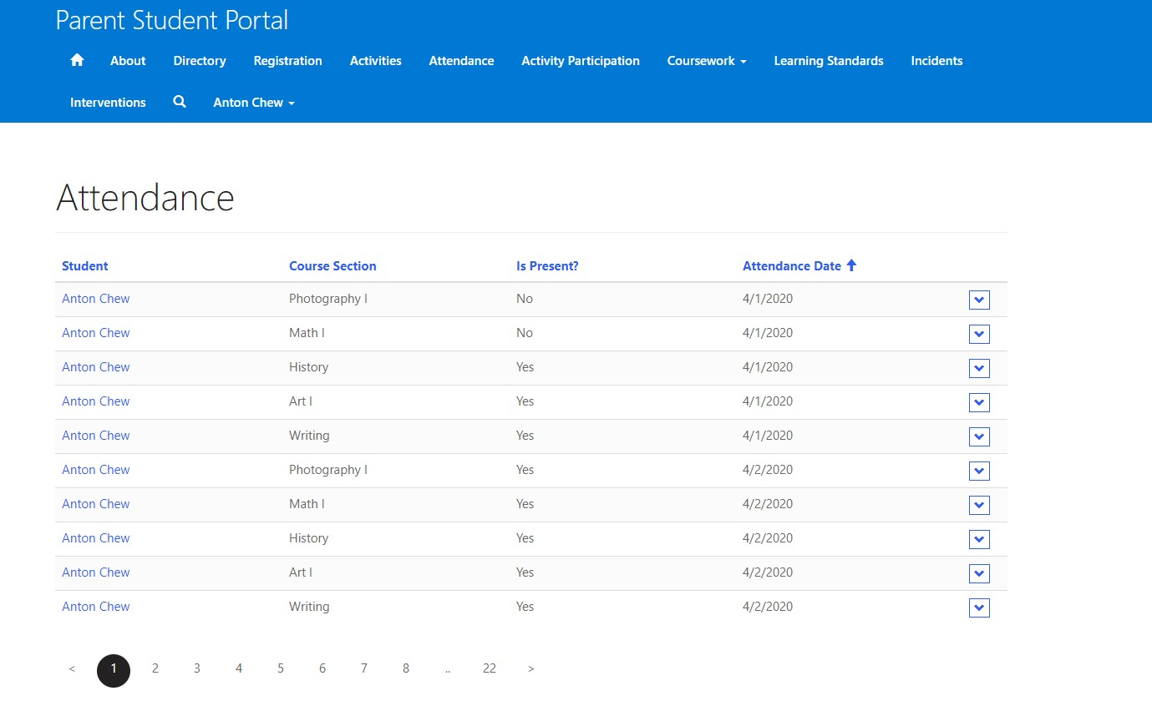

Anton is curious if he was marked absent from the classes he missed, so he checks his attendance.

## Step 2: Get involved via Extra Curricular Activities

Anton heard from a friend about an after-school club for Archery. He wants to learn more, so he looks at the Extra Curricular Activities to see this club as well as explore all the other activities offered at his school. Here he learns how to get involved.

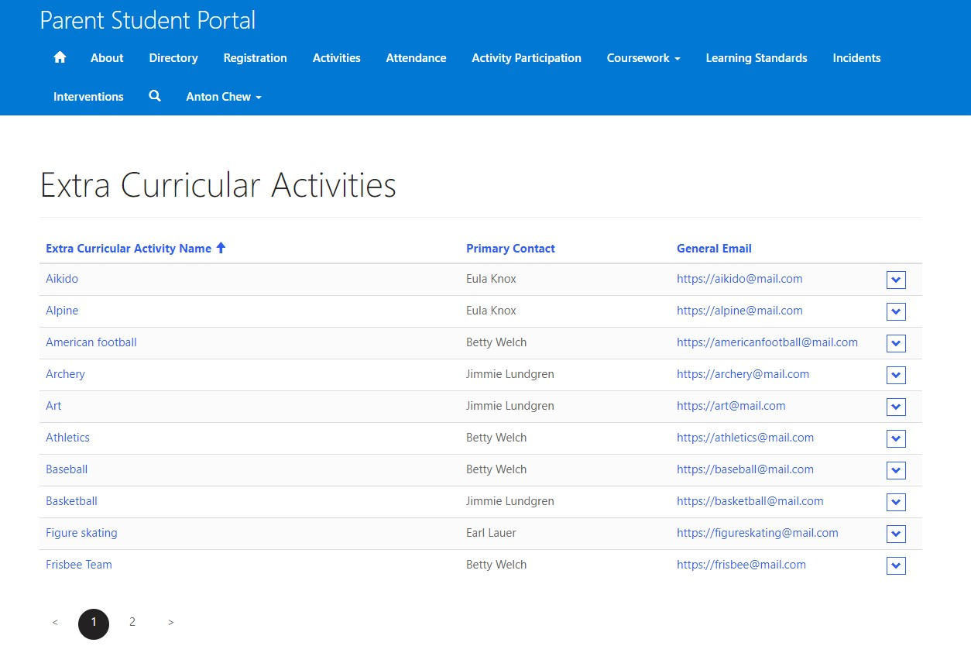

## Step 3: Paperwork in its place

Anton’s family just moved into a new home. His mom, Patricia realizes she needs to update the school with their new address and ask for a new bus route and pass. Just as Anton, she logs into the Parent Student Portal. She navigates to the Registration and updates their family information.

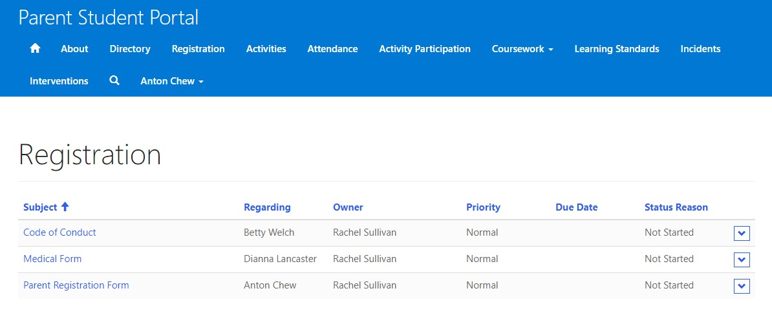

The student and parent journey continues through the roles of a school Administrator and an Educator who work to support the student and families.

## Walkthrough the Administrator and Educator Scenarios

## Step 1: K12 Model Drive App

Within the K12 scenario, Administrators have a complete view of Attendance, Courses, Internships,

Accomplishments, Extra-Curricular Activities, Interventions, Assessments, and Behavior incidents. The Administrator sees this single view to access information for their students and take informed actions to support students.

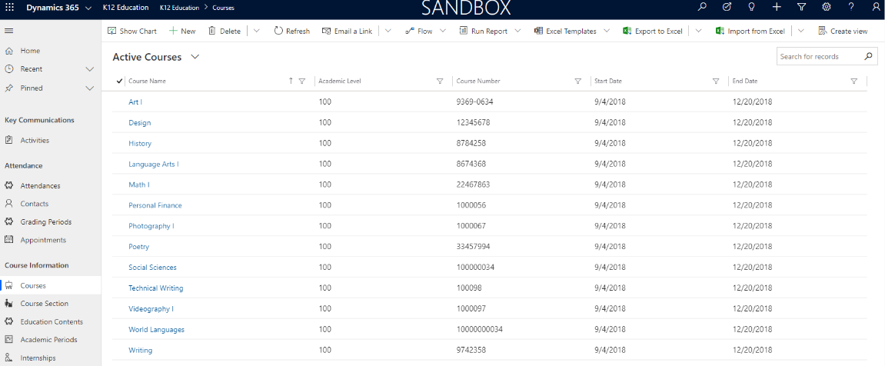

## Step 2: Engage your donors, raise funds

The Administrator looks at the donor app to view and manage donors and update them on the amazing ways their donations help their school.

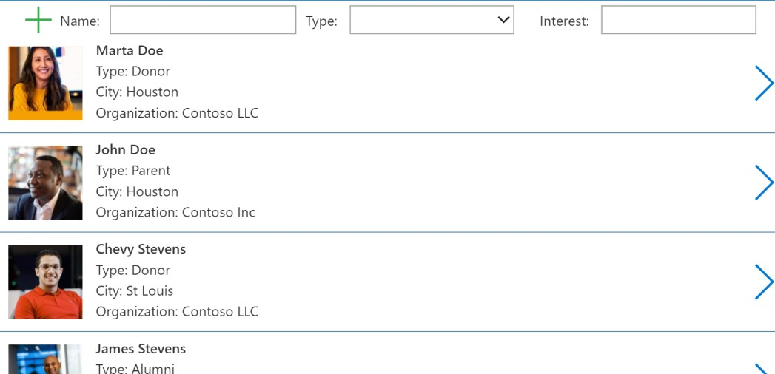

View the Administrator’s screen within the Donor App.

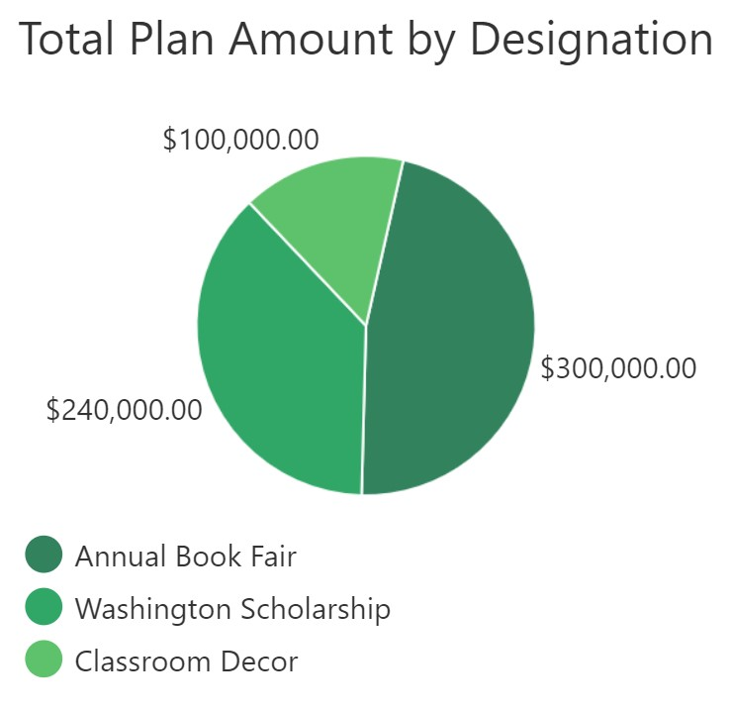

Through the donor app, the Administrator easily show donors, the impact of their donations, through a clear view of designation and how their donations are making an impact for students.

## Step 3: Student behavior management

The Administrator wants to encourage positive behavior from students, so they easily record and track the things that students are doing well according their school’s code of conduct.

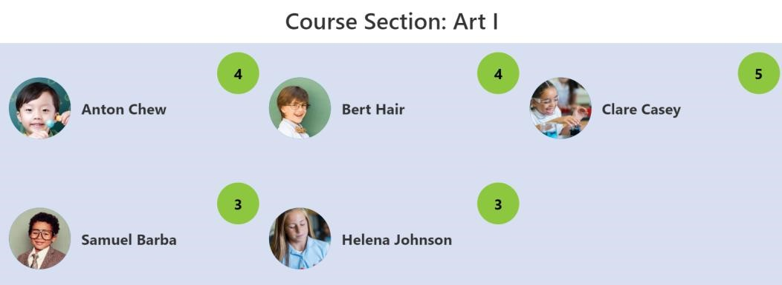

The Administrator looks at students who have demonstrated positive behavior in Art class.

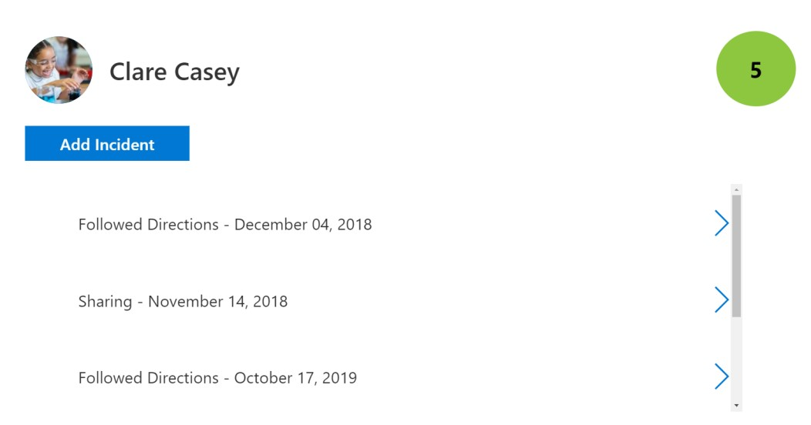

They click on Clare Casey to learn the exact actions that helped her earn the recognition of positive behavior in Art class.

## Step 4: Educator – Update Attendance Easily

The Educator easily tracks and reports attendance in the Attendance Application. This application can also be modified to use on a table or phone to increase ease of using it.

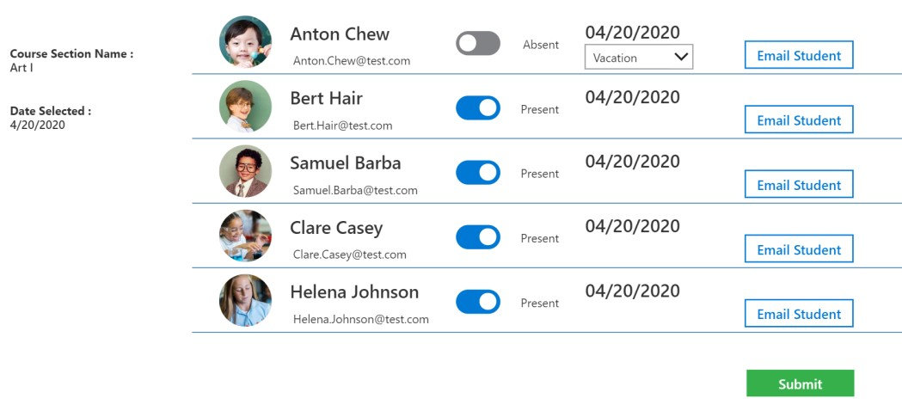

## Step 5: Educator – Analyze Attendance Patterns

Knowing that student attendance has an impact on student wellness and a student’s success in school, the educator straightforwardly monitors, analyzes, and acts on attendance data for their classes. They use the Attendance Power BI Report dashboard to view the attendance data for a date range in April for Art I class.

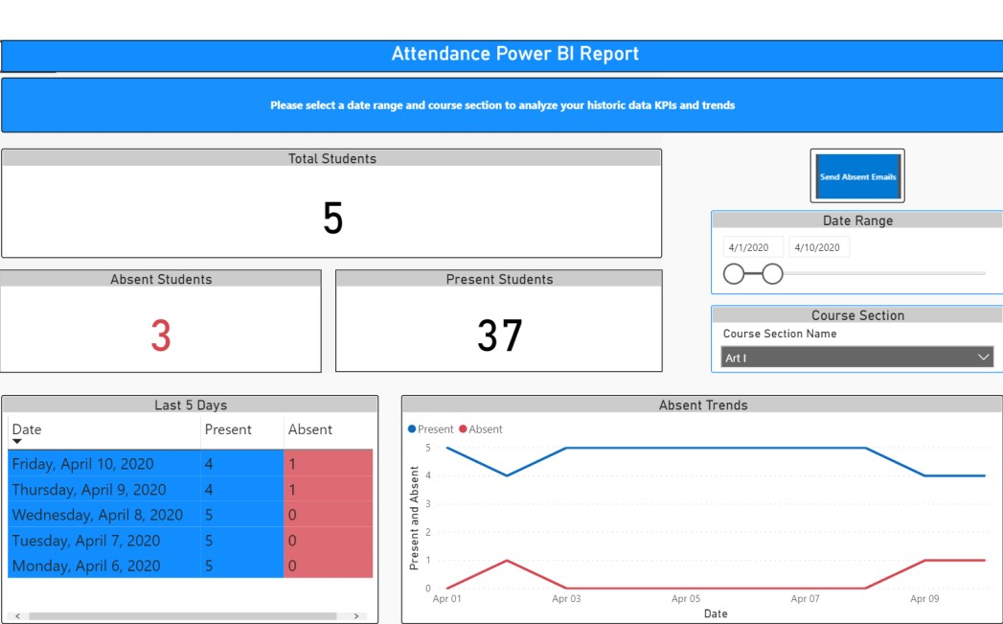

Thank you for taking the time to do a walkthrough of the K12 scenario and the experiences we have built for students, parents, administrators, and educators.